1. Download Android studio from online and install.
2. Import the android project.

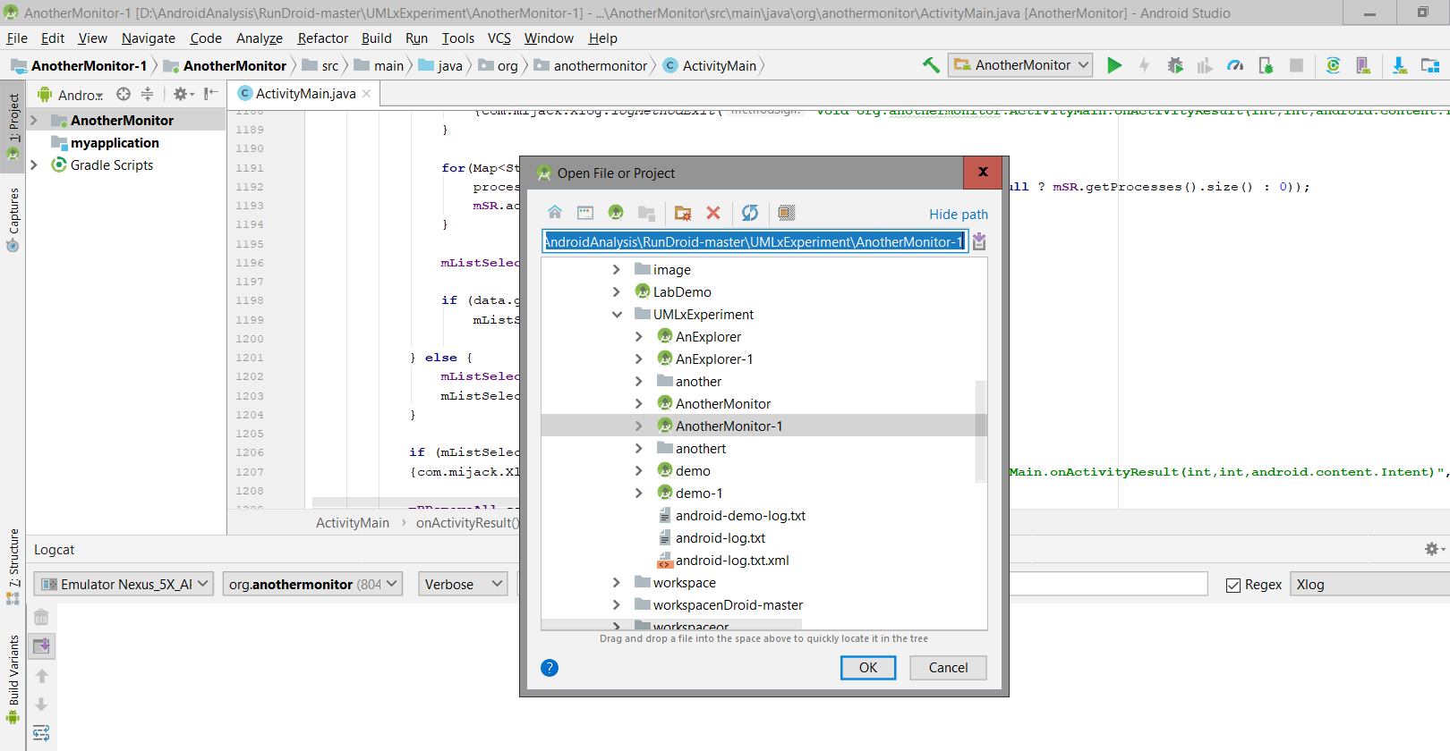

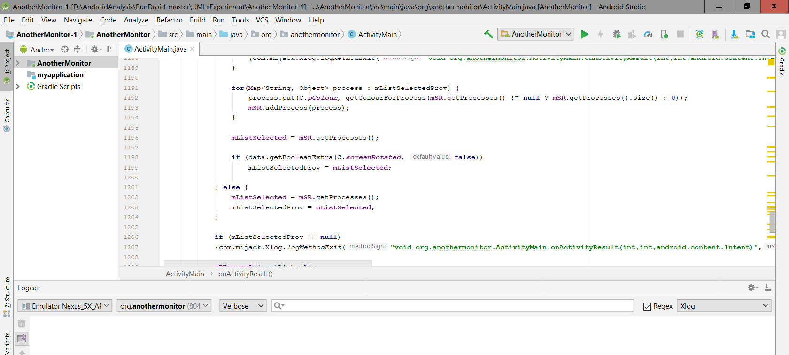

1. Solve any issues it may have from the build logs.

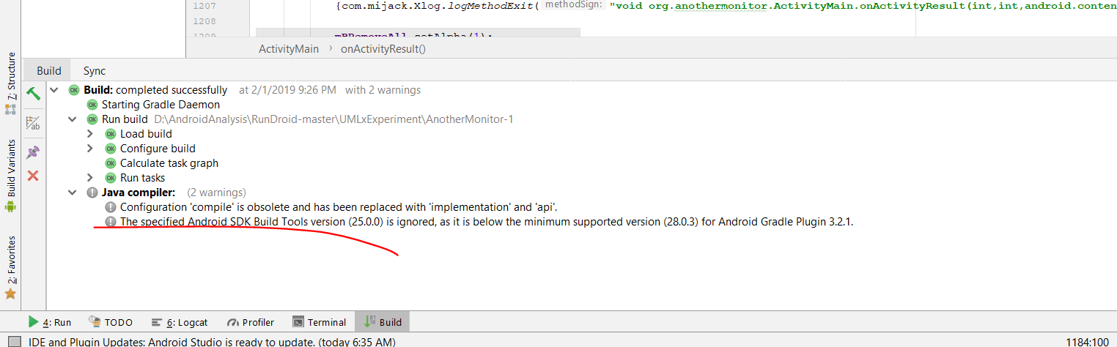

1. Compile and run the project

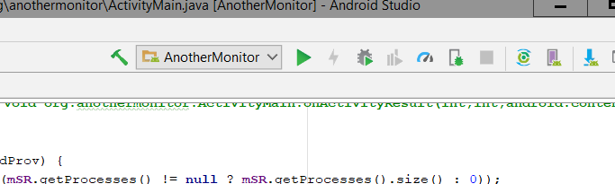

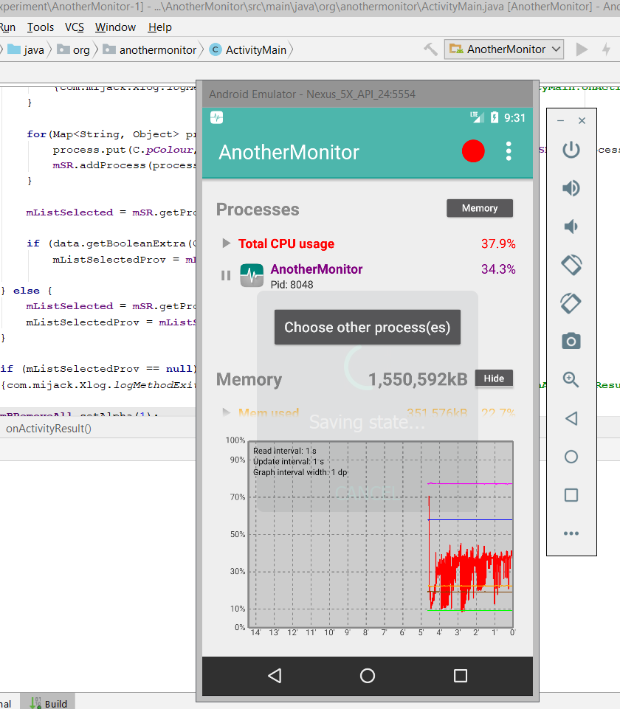

3. Export the apk following the path:

